1. 
2. We will develop the development environment to write our RESTful Application.   
   We will see the followings:
   1. Setting up development Environment.
   2. Writing RESTful App.
   3. Deploying
   4. Making a RESTful request.
   5. Responding to the RESTful request.
3. 
4. 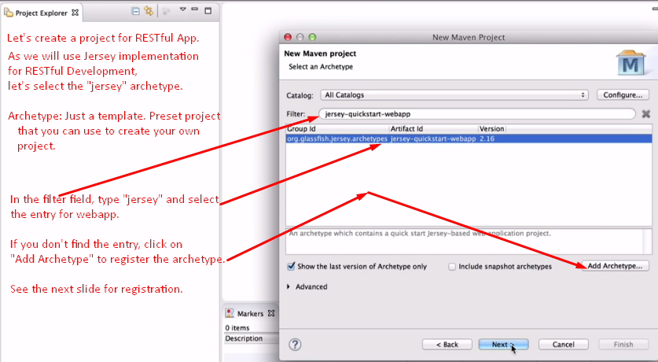 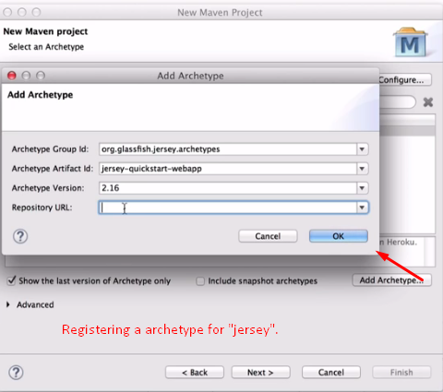  
   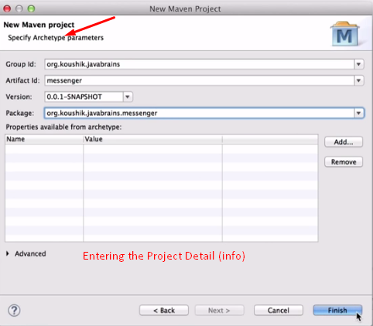 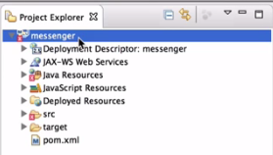 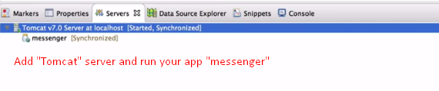 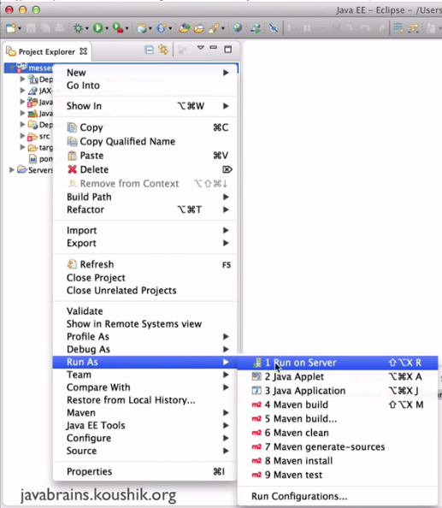 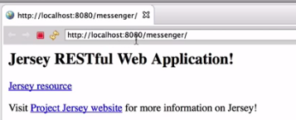
5. In the next lecture, we will see what is going on behind the scene.